|  | **SRI KRISHNA COLLEGE OF TECHNOLOGY**  **(An Autonomous Institution)**  **Approved by AICTE | Affiliated to Anna University Chennai|**  **Accredited by NBA - AICTE| Accredited by NAAC with ‘A’ Grade**  **KOVAIPUDUR, COIMBATORE 641042** |  |
| --- | --- | --- |

**LIFE INSURANCE MANAGEMENT**

## A PROJECT REPORT

***Submitted by***

|  |  |
| --- | --- |
| **SHREE HARINESH S -** | **727822TUCS216** |
|  |  |
|  |  |

***In partial fulfilment for the award of the degree of***

## BACHELOR OF ENGINEERING

## IN

**COMPUTER SCIENCE AND ENGINEERING**

**JULY 2024**

**BONAFIDE CERTIFICATE**

Certified that this project report **LIFE INSURANCE MANAGEMENT** is the bonafide work **SHREE HARINESH S 727822TUCS216** who carried out the project work under my supervision.

*SIGNATURE*

**Ms. A. GOMATHY**

**SUPERVISOR**

Assistant Professor,

Department of Computer Science and Engineering,

Sri Krishna College of Technology, Coimbatore-641042

*SIGNATURE*

**Dr. M. UDHAYAMURTHI**

**HEAD OF THE DEPARTMENT**

Associate Professor,

Department of Computer Science and Engineering,

Sri Krishna College of Technology, Coimbatore-641042

Certified that the candidate was examined by me in the Project Work Viva Voce

examination held on at Sri Krishna College of Technology,

Coimbatore-641042.

**INTERNAL EXAMINER EXTERNAL EXAMINER**

**ACKNOWLEDGEMENT**

First and foremost we thank the **Almighty** for being our light and for showering his gracious blessings throughout the course of this project.

We express our gratitude to our beloved Principal, **Dr. M.G. Sumithra,** for providing all facilities.

We are grateful to our beloved Head, Computing Sciences **Dr.T. Senthilnathan,** for her tireless and relentless support.

With the grateful heart, our sincere thanks to our Head of the Department **Dr. M. Udhayamurthi**, Department of Computer Science and Engineering for the motivation and all support to complete the project work.

We thank **Mr. A. Gomathy**, Assistant Professor, Department of Computer Science and Engineering, for his motivation and support.

We are thankful to all the **Teaching and Non-Teaching Staff** of Department of Computer Science and Engineering and to all those who have directly and indirectly extended their help to us in completing this project work successfully.

We extend our sincere thanks to our **family members** and our beloved **friends**, who had been strongly supporting us in all our endeavour

# ABSTRACT

Life Plus is an advanced life insurance website designed to simplify and enhance the process of purchasing and managing insurance policies. Utilizing modern web technologies such as React JS, Spring Boot, REST API, and MySQL, LifePlus offers a comprehensive platform for users to explore, apply for, and manage various insurance policies. The user-friendly interface ensures a seamless experience for both customers and administrators, with features tailored to meet their specific needs. Key functionalities include policy exploration, application processing, premium payment, and claim management. Customers can browse through a wide range of policies, compare benefits, and apply online with ease. The system supports secure payment processing for premium dues and facilitates quick and efficient claim submissions. Administrators have access to a powerful dashboard for policy management, user account oversight, and transaction tracking, ensuring smooth operations and enhanced customer service.

Life Plus leverages React JS for a dynamic and responsive frontend experience, while Spring Boot's robust RESTful APIs ensure reliable backend support. MySQL's scalable database architecture provides a solid foundation for managing extensive policy data and user information. Integrated email and real-time push notifications keep customers informed about policy updates, payment reminders, and claim statuses. The platform's advanced reporting tools offer administrators valuable insights into customer behaviour, policy trends, and financial metrics, aiding in strategic planning and resource allocation. Scalability is a key feature, allowing Life Plus to grow alongside its expanding user base and policy offerings.

In summary, Life Plus is a state-of-the-art solution tailored to the diverse needs of life insurance customers and administrators, promising a seamless, efficient, and user-centric experience. By automating and streamlining insurance processes, Life Plus significantly improves transparency, communication, and overall customer satisfaction within the insurance ecosystem.

**TABLE OF CONTENT**

|  |  |  |
| --- | --- | --- |
| **CHAPTER.NO** | **TITLE** | **PAGE NO** |
| 1 | INTRODUCTION | 1 |
|  | 1.1 PROJECT OVERVIEW | 1 |
|  | 1.2 SCOPE OF THE PROJECT | 1 |
|  | 1.3 OBJECTIVE | 1 |
| 2 | SYSTEM SPECIFICATIONS | 2 |
| 3 | SOFTWARE DEVELOPMENT LIFE CYCLE | 4 |
|  | 3.1 PHASES OF SDLC | 4 |
|  | 3.2 OVERVIEW OF SDLC | 4 |
| 4 | METHODOLOGIES | 6 |
| 5 | IMPLEMENTATION AND RESULT | 10 |
| 6 | CONCLUSION AND FUTURE SCOPE | 47 |
|  | 6.1 CONCLUSION | 47 |
|  | 6.2 FUTURE SCOPE | 47 |
| 7 | REFERENCES | 50 |

## LIST OF FIGURES

|  |  |  |  |  |  |
| --- | --- | --- | --- | --- | --- |
| **Figure No** | | | **TITLE** | **Page No** | |
|  | | |  |  | |
| 4.1 | User Flow Diagram | | | 6 | |
| 4.2 | Admin Flow Diagram | | | 7 | |
| 4.3 | Use Case Diagram | | | 8 | |
| 4.4 | Class Diagram | | | 9 | |
| 4.5 | Sequence Diagram | | | 9 | |
| 5.1 | Login page | | | 10 | |
| 5.2 | User Registration | | | 11 | |
| 5.3 | Admin Dashboard | | | 12 | |
| 5.4 | Admin Dashboard Users | | | 12 | |
| 5.5 | User Dashboard | | | 13 | |
| 5.6 | User Dashboard Policy Form | | | 13 | |
| 5.7 | User Dashboard FAQ | | | 14 | |
|  |  | | |  | |

## LIST OF ABBREVIATIONS

**Abbreviation Acronym**

**HTML** HYPERTEXT MARKUP LANGUAGE

**CSS** CASCADING STYLESHEET

**JS** JAVASCRIPT

**SDLC** SOFTWARE DEVELOPMENT LIFE CYCLE

**JWT** JSON WEB TOKEN

# CHAPTER 1 INTRODUCTION

This project aims to offer a seamless and efficient solution for customers and administrators to manage life insurance policies through an online platform. In this chapter, we will explore the problem statement, provide an overview, and outline the main objectives of the Life Plus insurance management system.

## PROBLEM STATEMENT

How can we develop a life insurance management system that allows customers to easily explore, apply for, and manage various insurance policies, while enabling administrators to efficiently oversee policy applications, premium payments, and claim processes, ensuring a user-friendly interface, secure transactions, and real-time notifications?

## OVERVIEW

In the realm of life insurance management, customers and administrators often face challenges such as navigating complex policy options, managing premium payments, and efficiently processing claims. Traditional methods can be cumbersome, error-prone, and lead to customer dissatisfaction. To address these issues, we propose the creation of LifePlus, a comprehensive life insurance management system. This system will leverage modern web technologies to provide a robust, user-friendly platform that simplifies policy exploration, application, payment, and claim management. By incorporating secure transactions, real-time notifications, and advanced reporting tools, LifePlus aims to enhance operational efficiency and customer satisfaction.

## OBJECTIVE

The primary objective of this project is to develop Life Plus, a life insurance management system that provides customers and administrators with a user-friendly and efficient platform for managing insurance policies. The system aims to streamline policy exploration, application, premium payments, and claim processing, while ensuring secure transactions, real-time notifications, and advanced reporting tools to enhance communication and operational efficiency.

# CHAPTER 2 SYSTEM SPECIFICATION

In this chapter, we are going to see the software that we have used to build the website. This chapter gives you a small description about the software used in the project.

## VS CODE

Visual Studio Code is a source code editor developed by Microsoft for Windows, Linux, and macOS. It includes support for debugging, embedded Git control, syntax highlighting, intelligent code completion, snippets, and code refactoring. It is also customizable, so users can change the editor's theme, keyboard shortcuts, and preferences.

VS Code is an excellent code editor for React projects. It is lightweight, customizable, and has a wide range of features that make it ideal for React development. It has built-in support for JavaScript, JSX, and TypeScript, and enables developers to quickly move between files and view detailed type definitions. It also has a built-in terminal for running tasks. Additionally, VS Code has an extensive library of extensions that allow developers to quickly add features like code snippets, debugging tools, and linting support to their projects.

## LOCAL STORAGE

Local storage is a type of web storage for storing data on the client side of a web browser. It allows websites to store data on a user’s computer, which can then be accessed by the website again when the user returns. Local storage is a more secure alternative to cookies because it allows websites to store data without having to send it back and forth with each request. Local storage is a key-value pair storage mechanism, meaning it stores data in the form of a key and corresponding value. It is similar to a database table in that it stores data in columns and rows, except that local storage stores the data in the browser rather than in a database. Local storage is often used to store user information such as

preferences and settings, or to store data that is not meant to be shared with other websites. It is also used to cache data to improve the performance of a website. Local storage is supported by all modern web browsers, including Chrome,

Firefox, Safari, and Edge. It is accessible through the browser’s JavaScript API. Local storage is a powerful tool for websites to store data on the client side. It is secure, efficient, and can be used to store data that does not need to be shared with other websites.

Local Storage is a great way to improve the performance of a website by caching data. Local storage in web browsers allows website data to be stored locally on the user’s computer. It is a way of persistently storing data on the client side, which is not sent to the server with each request. This allows users to store data such as preferences, login information, and form data without needing to send it to a server. It is typically stored in a browser’s cookie file, but it can also be stored in other locations such as HTML5 Local Storage and Indexed DB. The data stored in local storage is persistent and can be accessed by the website even if the user closes the browser or navigates to another page. It is a great way for websites to store user-specific data, as it is secure, reliable, and fast. It is also a great way for developers to store data that does not need to be sent to the server with each request.

One of the key benefits of using local storage is its reliability. Unlike server-side storage, which can be affected by network outages or other server issues, local storage is stored locally on the user’s machine, and so is not affected by these issues. Another advantage of local storage is its speed. Because the data is stored locally, it is accessed quickly, as there is no need to send requests to a server. This makes it ideal for storing data that needs to be accessed quickly, such as user preferences or session data. Local storage is also secure, as the data is stored on the user’s machine and not on a server. This means that the data is not accessible by anyone other than the user, making it a good choice for storing sensitive information.

# CHAPTER 3

# PROPOSED SYSTEM

This chapter gives a small description about the proposed idea behind the development of our website

## PROPOSED SYSTEM

The proposed Life Plus system offers a multitude of benefits from various perspectives. The online life insurance platform empowers customers to explore, apply for, and manage insurance policies efficiently, taking into account their specific needs and preferences. The system simplifies the entire insurance process, enabling customers to easily browse policies, submit applications, make premium payments, and manage claims online.

Once a policy application is submitted, it is directed to the designated personnel responsible for processing insurance applications. The administrative team ensures that applications are accurate and complete, with specialized staff members handling any necessary verifications or adjustments within a specified timeframe. Approved policies are updated in the system and are accessible to all relevant customers and administrators.

This system significantly reduces the administrative workload and streamlines operations in insurance management. Especially during peak periods or when dealing with complex policy applications, where manual processes may lead to delays or errors, the online platform mitigates such challenges. Customers can directly manage their policies and claims online, bypassing potential bottlenecks such as limited office hours or manual processing delays.

Moreover, the system enhances operational efficiency, enabling administrators to manage policy applications, payments, and claims promptly and effectively. By leveraging technology to automate data entry, verification, and notifications, the online insurance platform ensures swift and accurate processing, resulting in improved customer satisfaction and efficiency in policy management.

## ADVANTAGES

* Efficiency: The staff scheduling system allows administrators to create, modify, and manage schedules quickly and easily from anywhere with internet access. This eliminates the need for time-consuming manual processes, reducing administrative workload and saving time for both administrators and staff members.
* Flexibility: Staff members can update their availability and view their schedules online at their convenience. This flexibility helps accommodate varying schedules and preferences, improving staff satisfaction and allowing for more accurate scheduling.
* Conflict Resolution: The system automatically detects and resolves scheduling conflicts, ensuring that all shifts and duties are covered without overlapping. This reduces the chances of errors and double-bookings, leading to smoother operations.
* Accessibility: Administrators and staff can access the scheduling system from any location with internet access. This accessibility ensures that schedules can be managed and viewed remotely, facilitating better coordination and planning.
* Transparency: The system provides clear and detailed information about staff schedules, roles, and assignments. This transparency helps administrators and staff stay informed about their duties and responsibilities, reducing confusion and enhancing communication.
* Real-Time Notifications: Automated notifications keep staff members updated on schedule changes, upcoming duties, and important reminders. This feature ensures that everyone is informed in real-time, improving coordination and reducing the risk of missed tasks.

# CHAPTER 4 METHODOLOGIES

# 4.1 User FlowChart : -

Fig 4.1.Process flow diagram

**4.2 Admin FlowChart : -**

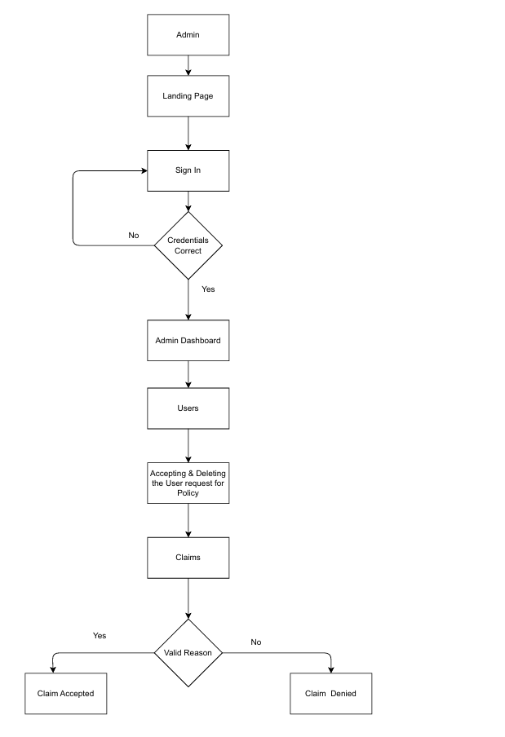

## User Registration: Customers register on the LifePlus platform by providing essential details such as name, email address, and password. Optional information like phone number and address may be included for better communication and policy management.

## Role-Based Access: Upon registration/login, users are assigned roles such as customer or administrator, which determine their access permissions and functionalities within the system.

## Policy Exploration: Users can explore available insurance policies by browsing through different categories or using search functionality to find policies that match their needs.

## Policy Application: Customers can apply for chosen insurance policies by submitting necessary personal and financial information. Administrators review these applications and verify the provided details.

## Premium Payment: Upon approval of the policy application, customers can make secure premium payments through the platform. The system processes these payments in real-time and updates the policy status.

## Claim Request: Customers can submit claims by providing relevant details and documentation. Administrators review these claims and proceed to process them accordingly.

## Notification: After processing, the system generates notifications about policy updates, payment confirmations, or claim statuses. Customers receive confirmation of new policies, successful payments, or claim resolutions.

## Policy Management: Administrators review and manage policy applications, premium payments, and claims. The system updates the policy status and notifies all relevant users about any changes.

## Real-Time Updates: Customers receive real-time updates and reminders about premium due dates, policy renewals, and claim statuses.

## Feedback and Adjustments: After interacting with the platform, customers can provide feedback on their experience. Administrators can make adjustments based on this feedback to improve the system.

## 4.3 Use Case Diagram:

The use case diagram illustrates a Life Insurance Management System, depicting various user roles including Clients and Administrators. Each role has specific functionalities to efficiently manage insurance policies, payments, and claims. The diagram emphasizes interaction points for roles to perform tasks like policy management, claim processing, and user account management, showcasing the workflow and the interplay between different users and system features for seamless insurance operations. 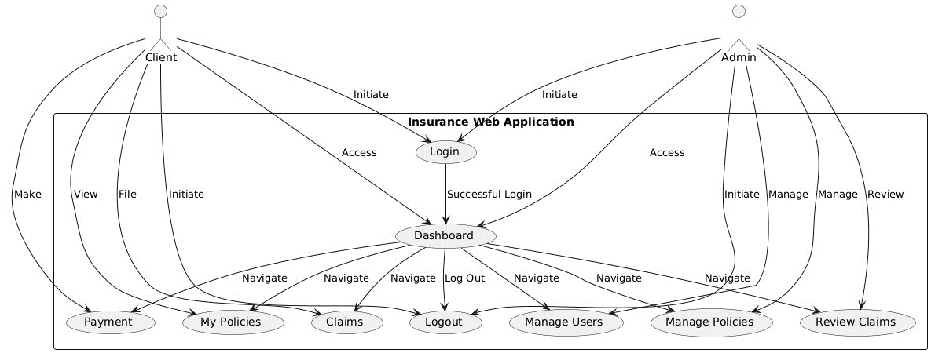

4.2 Use Case Diagram

**4.4 Class Diagram:**

The class diagram outlines the architecture of the **Insurance Management System**, detailing the roles and their specific functionalities. Key classes include **Policy**, **Claim**, **User**, and **Admin**, each interacting with various attributes and methods related to policy management, claims processing, and user actions. This diagram highlights methods for managing policies, claims, user authentication, and administrative tasks, illustrating how each role contributes to the system's operations.

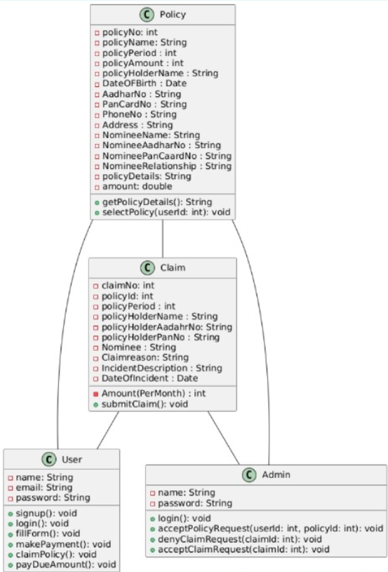

4.3 Class Diagram

**4.5 Sequence Diagram:**

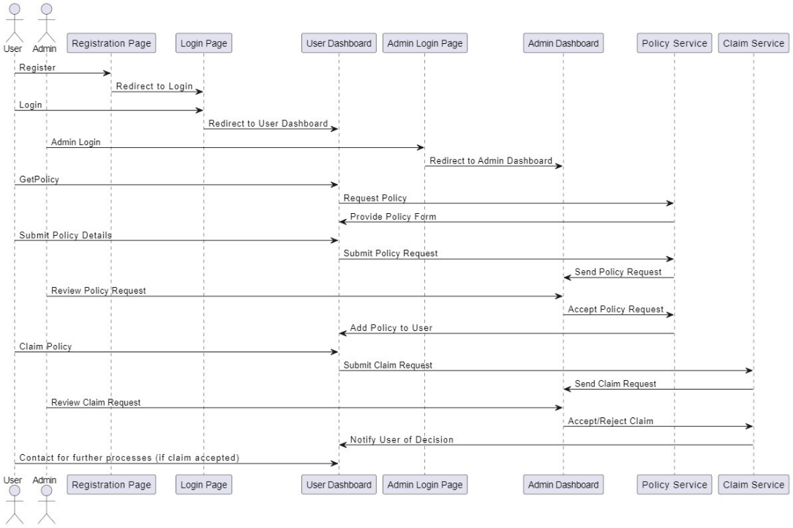The sequence diagram illustrates the process for users and administrators to manage policies and claims in the Insurance Management System. The diagram shows interactions between users (both regular users and admins) and various system components such as the registration page, login page, user dashboard, admin dashboard, policy service, and claim service. It highlights key activities including user registration, policy requests, and claims processing.

4.4 Sequence Diagram

**CHAPTER 5 IMPLEMENTATION AND RESULT**

This chapter gives a description about the output that we produced by developing the website of our idea.

## LOGIN

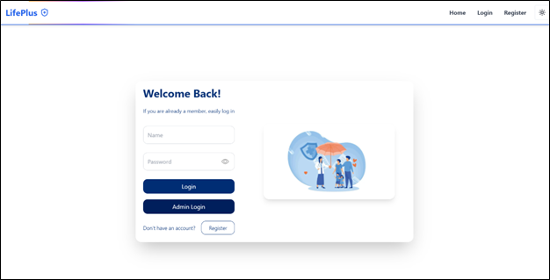When User enters our website he will be asked about his login details like User Name and password. The login details will be verified with the details given while the user creates an account.

Fig 5.1 LOGIN PAGE

## USER REGISTER

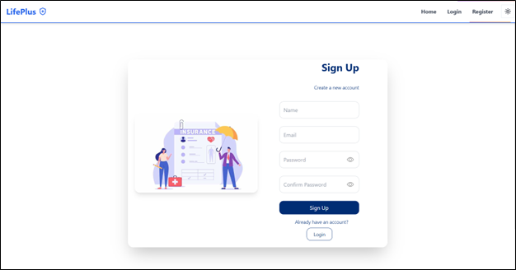

Fig 5.2 USER REGISTER

## ADMIN DASHBOARD

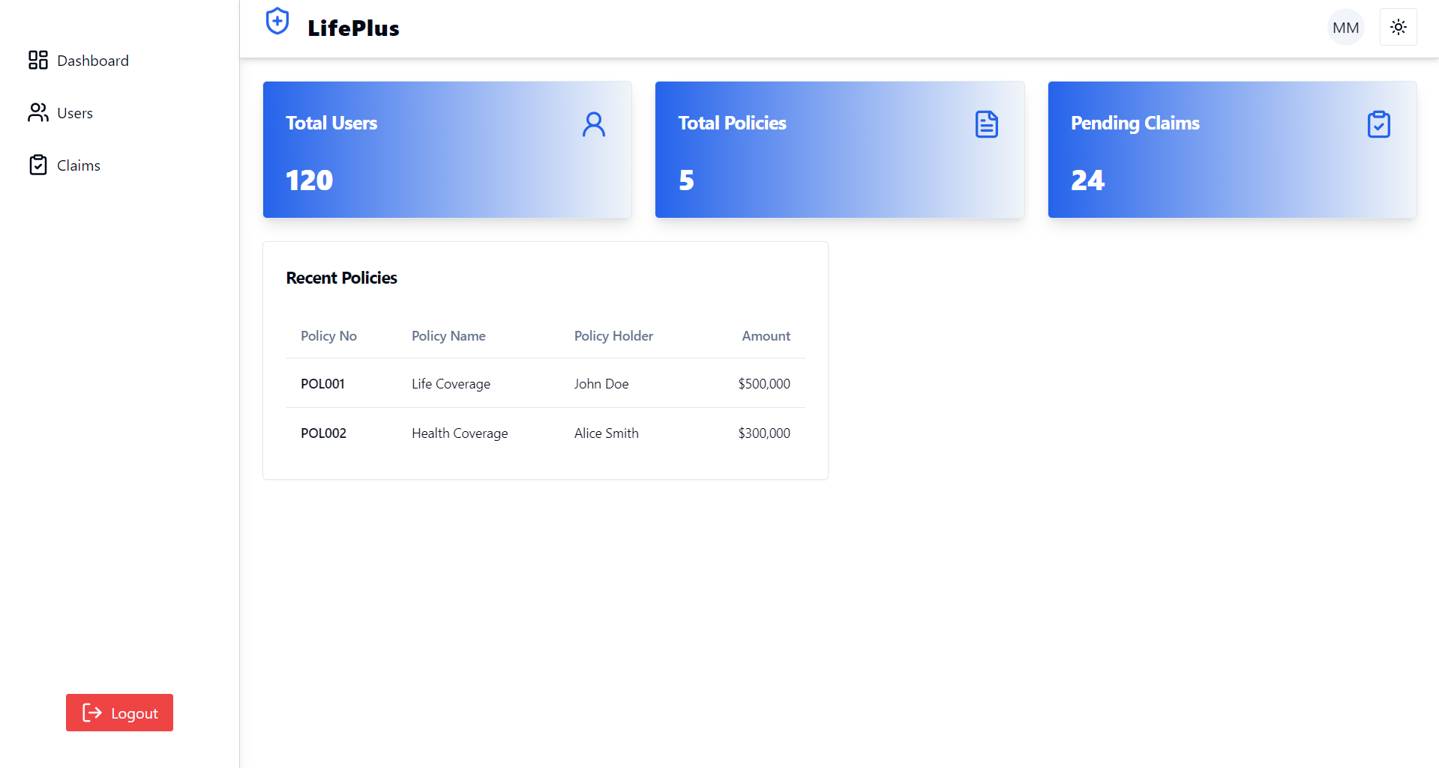

Fig 5.3 Admin Dashboard

## ADMIN DASHBOARD

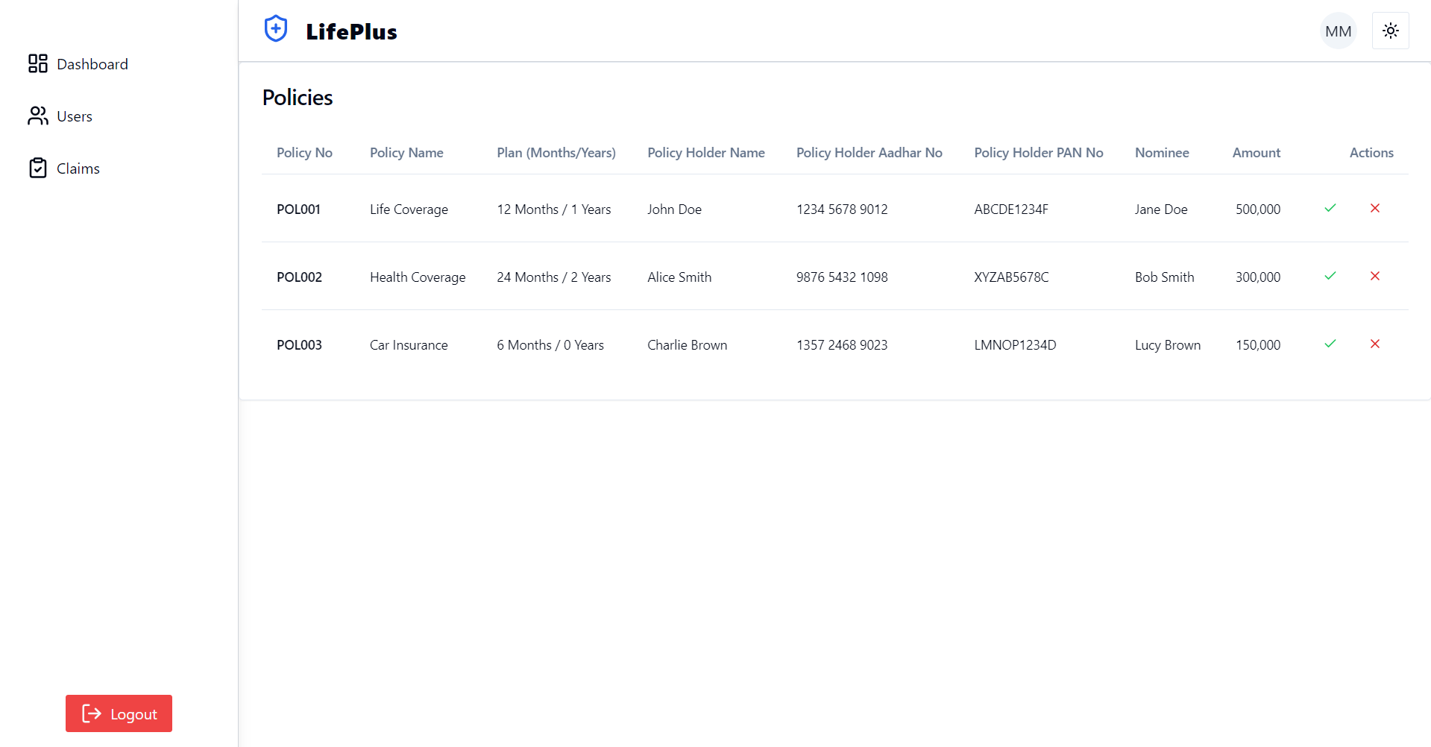

Fig 5.4 Admin Dashboard Users Page

## USER DASHBOARD

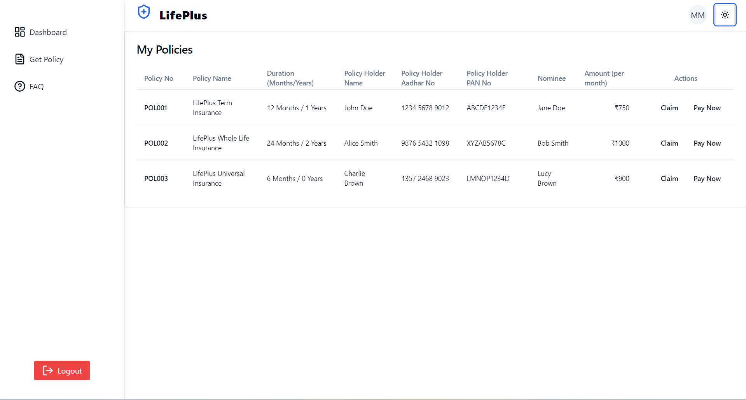

Fig 5.5 User Dashboard

## ADMIN DASHBOARD

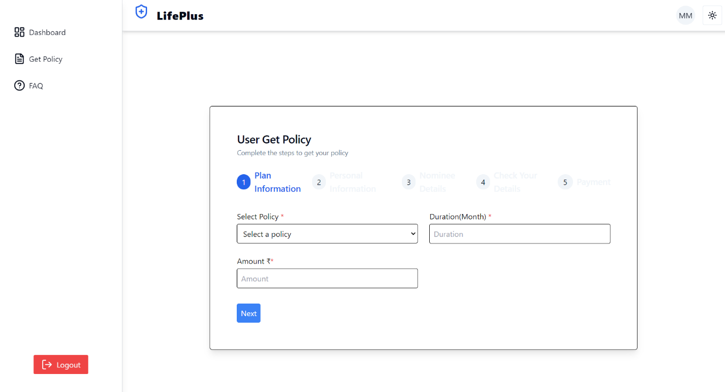

Fig 5.6 User Dashboard Policy Form

## FAQ PAGE

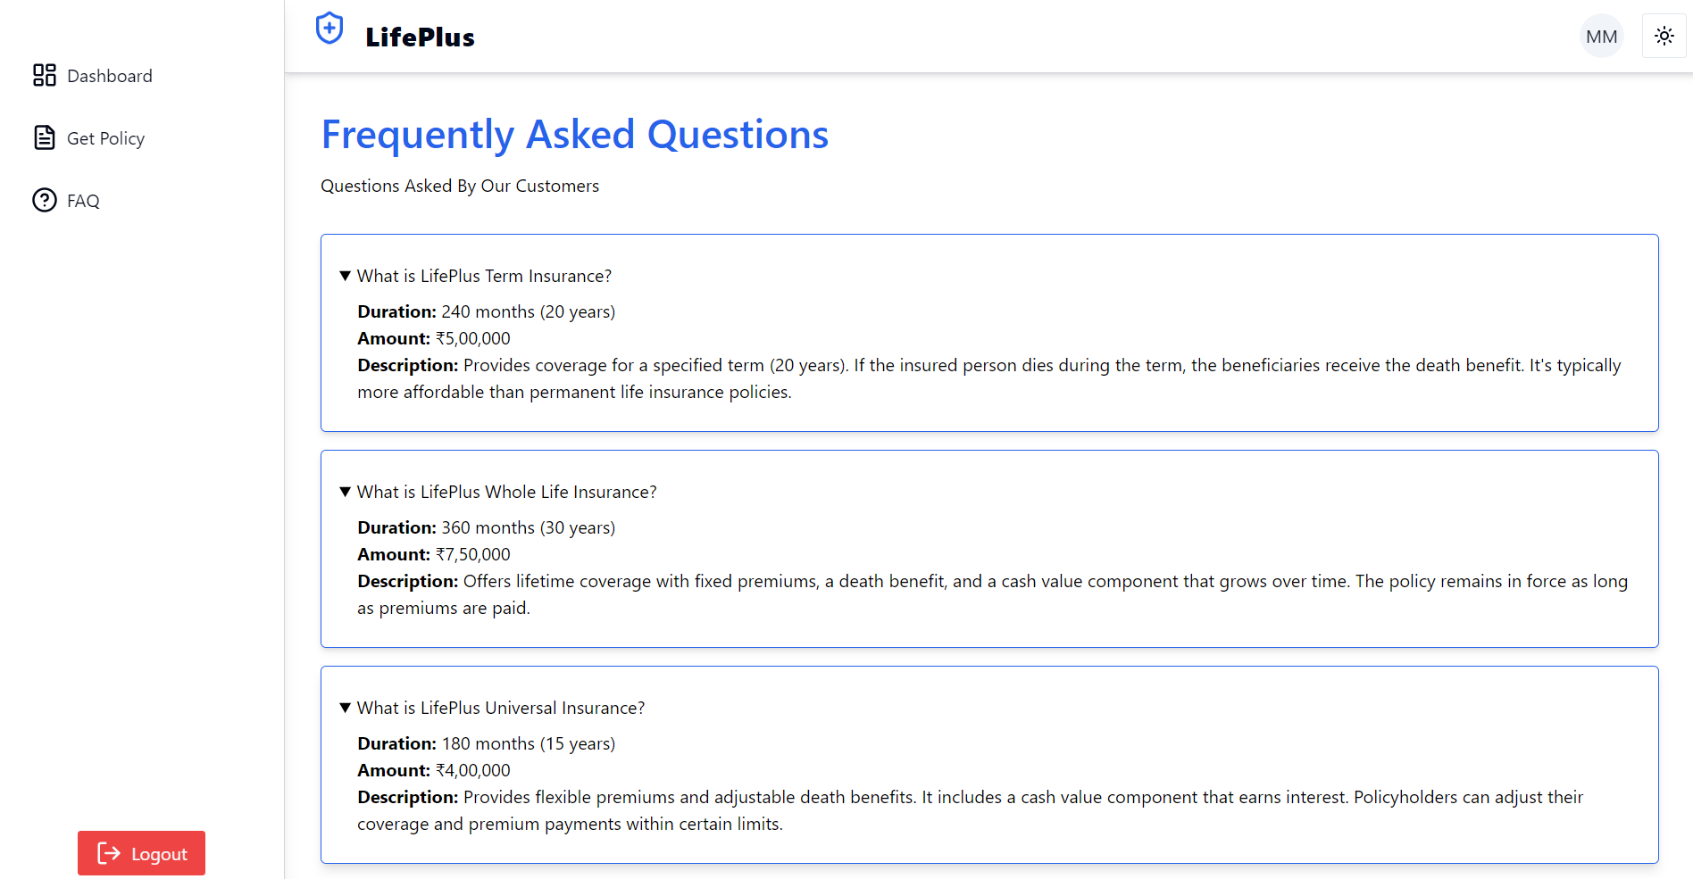

Fig 5.7 FAQ Page

## 5.8 CODING

### Config:

### @Configuration @RequiredArgsConstructor public class ApplicationConfig { private final UserRepo userRepo; @Bean public UserDetailsService userDetailsService(){ return username -> userRepo.findByEmail(username) .orElseThrow(() -> new UsernameNotFoundException("User not Found")); } @Bean public AuthenticationProvider authenticationProvider(){ DaoAuthenticationProvider authProvider = new DaoAuthenticationProvider(); authProvider.setUserDetailsService(userDetailsService()); authProvider.setPasswordEncoder(passwordEncoder()); return authProvider; } @Bean public AuthenticationManager authenticationManager(AuthenticationConfiguration config) throws Exception { return config.getAuthenticationManager(); } @Bean public PasswordEncoder passwordEncoder() { return new BCryptPasswordEncoder(); } }

### @Configuration public class CorsConfig { @Bean public WebMvcConfigurer corsConfigurer() { return new WebMvcConfigurer() { @Override public void addCorsMappings(CorsRegistry registry) { registry.addMapping("/**") .allowedOrigins("localhost:5173") .allowedMethods("GET", "POST", "PUT", "DELETE", "OPTIONS") .allowedHeaders("*") .allowCredentials(true); } }; } }

### @Component @RequiredArgsConstructor public class JwtAuthenticationFilter extends OncePerRequestFilter { private final JwtService jwtService; private final UserDetailsService userDetailsService; @Override protected void doFilterInternal( @NonNull HttpServletRequest request, @NonNull HttpServletResponse response, @NonNull FilterChain filterChain) throws ServletException, IOException { final String authHeader =request.getHeader("Authorization"); final String jwtToken; final String userEmail; if(authHeader == null || !authHeader.startsWith("Bearer ")) { filterChain.doFilter(request,response); return; } jwtToken = authHeader.substring(7); userEmail = jwtService.extractUserName(jwtToken);if(userEmail != null && SecurityContextHolder.*getContext*().getAuthentication() == null){ UserDetails userDetails = this.userDetailsService.loadUserByUsername(userEmail); if(jwtService.isTokenValid(jwtToken, userDetails)){ UsernamePasswordAuthenticationToken authToken = new UsernamePasswordAuthenticationToken( userDetails, null, userDetails.getAuthorities() ); authToken.setDetails( new WebAuthenticationDetailsSource().buildDetails(request) ); SecurityContextHolder.*getContext*().setAuthentication(authToken); } } filterChain.doFilter(request,response); } }

### @Service public class JwtService { private static final String *SECRET_KEY* = "EbeEsh7VhXpHMAkLz7Xb3TYm7a4KLMlYn0Kr1NJEhTIOeU9HJsv3t2bMa5OjoiaD"; public String extractUserName(String token) { return extractClaim(token, Claims::getSubject); } public <T> T extractClaim(String token, Function<Claims, T> claimsResolver){ final Claims claims = extractAllClaims(token); return claimsResolver.apply(claims); } public String generateToken(UserDetails userDetails){ return generateToken(new HashMap<>(), userDetails); } public String generateToken( Map<String, Object> extraClaims, UserDetails userDetails ){ return Jwts .*builder*() .claims(extraClaims). subject(userDetails.getUsername()) .issuedAt(new Date(System.*currentTimeMillis*())) .expiration(new Date(System.*currentTimeMillis*() + 1000 * 60 * 24)) .signWith(getSignInKey(), SignatureAlgorithm.*HS256*) .compact(); } public Boolean isTokenValid(String token ,UserDetails userDetails) { final String username = extractUserName(token); return (username.equals(userDetails.getUsername()) && !isTokenExpired(token)); } private boolean isTokenExpired(String token) { return extractExpiration(token).before(new Date()); } private Date extractExpiration(String token) { return extractClaim(token, Claims::getExpiration); } private Claims extractAllClaims(String token) { return Jwts .*parser*() .setSigningKey(getSignInKey()) .build() .parseClaimsJws(token) .getBody(); } private Key getSignInKey() { byte[] keyByte = Decoders.*BASE64*.decode(*SECRET_KEY*); return Keys.*hmacShaKeyFor*(keyByte); } }

### @Configuration public class LogoutConfiguration { @Bean public CustomLogoutHandler logoutHandler(TokenRepo tokenRepo, JwtService jwtService) { return new CustomLogoutHandler(tokenRepo, jwtService); } @Bean public LogoutSuccessHandler logoutSuccessHandler() { return new CustomLogoutSuccessHandler(); } }

### Home page:

### @Entity

### @AllArgsConstructor

### @NoArgsConstructor

### @Getter

### @Setter

### @Builder

### public class Customer implements UserDetails {

### @GeneratedValue(strategy = GenerationType.SEQUENCE)

### @Id

### private Long id;

### private String name;

### private String email;

### private String password;

### @JsonBackReference

### @OneToMany(mappedBy = "customer", cascade = CascadeType.ALL, fetch = FetchType.LAZY)

### private List<Token> tokens;

### @Enumerated(EnumType.STRING)

### private Role role;

### @Override

### public Collection<? extends GrantedAuthority> getAuthorities() {

### return List.of(new SimpleGrantedAuthority(role.name()));

### }

### @Override

### public String getUsername() {

### return email;

### }

### @Override

### public boolean isAccountNonExpired() {

### return true;

### }

### @Override

### public boolean isAccountNonLocked() {

### return true;

### }

### @Override

### public boolean isCredentialsNonExpired() {

### return true;

### }

### @Override

### public boolean isEnabled() {

### return true;

### }

### }

### 

### @Builder @AllArgsConstructor @NoArgsConstructor @Getter @Setter @Entity public class Schedule { @Id @GeneratedValue(strategy = GenerationType.*SEQUENCE*) private Long id; private String title; private LocalDateTime date; private LocalDateTime time; private String assignedTo; @ManyToOne(fetch = FetchType.*LAZY*) @JoinColumn(name = “user_id”) @JsonIgnore private User user; @ManyToOne(fetch = FetchType.*LAZY*) @JoinColumn(name = “cutomer_mail”) @JsonIgnore private Customer customer; }

### UserDashboard.jsx : -

### import React, { useState, useEffect } from 'react';

### import { Plus } from 'lucide-react';

### import {

### Table,

### TableBody,

### TableHead,

### TableHeader,

### TableRow,

### TableCell,

### } from "@/components/ui/table";

### import { Button } from "@/components/ui/button";

### import {

### Card,

### CardContent,

### CardHeader,

### CardTitle,

### } from "@/components/ui/card";

### import { Input } from "@/components/ui/input";

### import { Label } from "@/components/ui/label";

### import {

### Sheet,

### SheetContent,

### SheetHeader,

### SheetTitle,

### SheetDescription,

### SheetFooter,

### } from "@/components/ui/sheet";

### import { toast, ToastContainer } from 'react-toastify';

### import 'react-toastify/dist/ReactToastify.css';

### const UserDashboard = () => {

### const [open, setOpen] = useState(false);

### const [selectedPolicy, setSelectedPolicy] = useState(null);

### const [action, setAction] = useState(null);

### const [formValues, setFormValues] = useState({});

### const [formErrors, setFormErrors] = useState({});

### const [isFormValid, setIsFormValid] = useState(false);

### const policies = [

### {

### policyNo: "POL001",

### policyName: "LifePlus Term Insurance",

### planMonths: 12,

### planYears: 1,

### policyHolderName: "John Doe",

### policyHolderAadhar: "1234 5678 9012",

### policyHolderPAN: "ABCDE1234F",

### nominee: "Jane Doe",

### amount: "₹750",

### status: "",

### },

### {

### policyNo: "POL002",

### policyName: "LifePlus Whole Life Insurance",

### planMonths: 24,

### planYears: 2,

### policyHolderName: "Alice Smith",

### policyHolderAadhar: "9876 5432 1098",

### policyHolderPAN: "XYZAB5678C",

### nominee: "Bob Smith",

### amount: "₹1000",

### status: "",

### },

### {

### policyNo: "POL003",

### policyName: "LifePlus Universal Insurance",

### planMonths: 6,

### planYears: 0,

### policyHolderName: "Charlie Brown",

### policyHolderAadhar: "1357 2468 9023",

### policyHolderPAN: "LMNOP1234D",

### nominee: "Lucy Brown",

### amount: "₹900",

### status: "",

### },

### ];

### useEffect(() => {

### validateForm();

### }, [formValues]);

### const openSheetWithPolicy = (policy, actionType) => {

### setSelectedPolicy(policy);

### setAction(actionType);

### setOpen(true);

### setFormValues({});

### setFormErrors({});

### };

### const handleInputChange = (e) => {

### const { id, value } = e.target;

### setFormValues({ ...formValues, [id]: value });

### };

### const validateForm = () => {

### const errors = {};

### const requiredFields = action === 'Claim'

### ? ['claimReason', 'additionalDetails', 'dateOfIncident']

### : ['cardNumber', 'cname', 'expirydate', 'cvv'];

### requiredFields.forEach(field => {

### if (!formValues[field]) {

### errors[field] = 'This field is required';

### }

### });

### setFormErrors(errors);

### setIsFormValid(Object.keys(errors).length === 0);

### };

### const handleSubmit = () => {

### if (action === 'Claim') {

### toast.info("Your claim is being processed. You will be notified shortly.");

### } else {

### toast.success("Payment successful", {

### icon: "✔️",

### });

### }

### setOpen(false);

### };

### 

### return (

### <>

### <Card>

### <CardHeader className='w-full flex flex-row justify-between items-center'>

### <CardTitle> My Policies</CardTitle>

### </CardHeader>

### <CardContent>

### <Table>

### <TableHeader>

### <TableRow>

### <TableHead className="w-[100px]">Policy No</TableHead>

### <TableHead>Policy Name</TableHead>

### <TableHead>Duration (Months/Years)</TableHead>

### <TableHead>Policy Holder Name</TableHead>

### <TableHead>Policy Holder Aadhar No</TableHead>

### <TableHead>Policy Holder PAN No</TableHead>

### <TableHead>Nominee</TableHead>

### <TableHead>Amount (per month)</TableHead>

### <TableHead className="text-center w-[200px]">Actions</TableHead>

### </TableRow>

### </TableHeader>

### <TableBody>

### {policies.map((policy) => (

### <TableRow key={policy.policyNo}>

### <TableCell className="font-medium">{policy.policyNo}</TableCell>

### <TableCell>{policy.policyName}</TableCell>

### <TableCell>{policy.planMonths} Months / {policy.planYears} Years</TableCell>

### <TableCell>{policy.policyHolderName}</TableCell>

### <TableCell>{policy.policyHolderAadhar}</TableCell>

### <TableCell>{policy.policyHolderPAN}</TableCell>

### <TableCell>{policy.nominee}</TableCell>

### <TableCell className="text-right">{policy.amount}</TableCell>

### <TableCell className="text-right">

### <Button variant="ghost" size="sm" className="mr-2 bg-customGreen rounded-3xl" onClick={() => openSheetWithPolicy(policy, 'Claim')}>

### Claim

### </Button>

### <Button variant="ghost" size="sm" className="bg-customGreen rounded-3xl" onClick={() => openSheetWithPolicy(policy, 'Pay')}>

### Pay Now

### </Button>

### </TableCell>

### </TableRow>

### ))}

### </TableBody>

### </Table>

### </CardContent>

### </Card>

### <Sheet open={open} onOpenChange={() => setOpen(false)}>

### <SheetContent>

### <SheetHeader>

### <SheetTitle>{action === 'Claim' ? 'Claim Policy' : 'Pay Policy'}</SheetTitle>

### <SheetDescription>

### {action === 'Claim' ? 'Provide details for your claim.' : 'Enter payment details.'}

### </SheetDescription>

### </SheetHeader>

### <div className="grid gap-4 py-4">

### {selectedPolicy && (

### <>

### <div className="grid grid-cols-4 items-center gap-4">

### <Label htmlFor="policyNo" className="text-right">

### Policy No

### </Label>

### <Input id="policyNo" value={selectedPolicy.policyNo} disabled className="col-span-3" />

### </div>

### <div className="grid grid-cols-4 items-center gap-4">

### <Label htmlFor="policyName" className="text-right">

### Policy Name

### </Label>

### <Input id="policyName" value={selectedPolicy.policyName} disabled className="col-span-3" />

### </div>

### {action === 'Claim' && (

### <>

### <div className="grid grid-cols-4 items-center gap-4">

### <Label htmlFor="claimReason" className="text-right">

### Claim Reason

### </Label>

### <Input

### id="claimReason"

### className={`col-span-3 ${formErrors.claimReason ? 'border-red-500' : ''}`}

### placeholder="Enter reason for claim"

### value={formValues.claimReason || ''}

### onChange={handleInputChange}

### />

### {formErrors.claimReason && <span className="col-span-3 text-red-500">{formErrors.claimReason}</span>}

### </div>

### <div className="grid grid-cols-4 items-center gap-4">

### <Label htmlFor="additionalDetails" className="text-right">

### Incident Description

### </Label>

### <Input

### id="additionalDetails"

### className={`col-span-3 ${formErrors.additionalDetails ? 'border-red-500' : ''}`}

### placeholder="Enter Incident description"

### value={formValues.additionalDetails || ''}

### onChange={handleInputChange}

### />

### {formErrors.additionalDetails && <span className="col-span-3 text-red-500">{formErrors.additionalDetails}</span>}

### </div>

### <div className="grid grid-cols-4 items-center gap-4">

### <Label htmlFor="dateOfIncident" className="text-right">

### Date of incident

### </Label>

### <Input

### id="dateOfIncident"

### type="date"

### className={`col-span-3 ${formErrors.dateOfIncident ? 'border-red-500' : ''}`}

### value={formValues.dateOfIncident || ''}

### onChange={handleInputChange}

### />

### {formErrors.dateOfIncident && <span className="col-span-3 text-red-500">{formErrors.dateOfIncident}</span>}

### </div>

### </>

### )}

### {action === 'Pay' && (

### <>

### <div className="grid grid-cols-4 items-center gap-4">

### <Label htmlFor="cardNumber" className="text-right">

### Card Number

### </Label>

### <Input

### id="cardNumber"

### className={`col-span-3 ${formErrors.cardNumber ? 'border-red-500' : ''}`}

### placeholder="Enter Card Number"

### value={formValues.cardNumber || ''}

### onChange={handleInputChange}

### />

### {formErrors.cardNumber && <span className="col-span-3 text-red-500">{formErrors.cardNumber}</span>}

### </div>

### <div className="grid grid-cols-4 items-center gap-4">

### <Label htmlFor="cname" className="text-right">

### Name on Card

### </Label>

### <Input

### id="cname"

### className={`col-span-3 ${formErrors.cname ? 'border-red-500' : ''}`}

### placeholder="Enter Card Holder Name"

### value={formValues.cname || ''}

### onChange={handleInputChange}

### />

### {formErrors.cname && <span className="col-span-3 text-red-500">{formErrors.cname}</span>}

### </div>

### <div className="grid grid-cols-4 items-center gap-4">

### <Label htmlFor="expirydate" className="text-right">

### Expiry date

### </Label>

### <Input

### id="expirydate"

### type="text"

### placeholder="MM/YY"

### className={`col-span-3 ${formErrors.expirydate ? 'border-red-500' : ''}`}

### value={formValues.expirydate || ''}

### onChange={handleInputChange}

### />

### {formErrors.expirydate && <span className="col-span-3 text-red-500">{formErrors.expirydate}</span>}

### </div>

### <div className="grid grid-cols-4 items-center gap-4">

### <Label htmlFor="cvv" className="text-right">

### CVV

### </Label>

### <Input

### id="cvv"

### type="password"

### className={`col-span-3 ${formErrors.cvv ? 'border-red-500' : ''}`}

### placeholder="Enter CVV"

### value={formValues.cvv || ''}

### onChange={handleInputChange}

### />

### {formErrors.cvv && <span className="col-span-3 text-red-500">{formErrors.cvv}</span>}

### </div>

### </>

### )}

### </>

### )}

### </div>

### <SheetFooter className='flex flex-col flex-1'>

### <Button className='w-1/2 bg-destructive hover:bg-destructive/80' onClick={() => setOpen(false)}>Cancel</Button>

### <Button

### type="button"

### className='w-1/2'

### onClick={handleSubmit}

### disabled={!isFormValid}

### >

### {action === 'Claim' ? 'Submit Claim' : 'Pay Now'}

### </Button>

### </SheetFooter>

### </SheetContent>

### </Sheet>

### <ToastContainer />

### </>

### );

### };

### export default UserDashboard;

### Admin Dashboard.jsx : -

### import React, { useState } from 'react';

### import { Card, CardHeader, CardContent, CardTitle } from '@/components/ui/card';

### import { BarChart, User2, FileText, Plus, Edit, Trash2 } from 'lucide-react';

### import {

### Table, TableBody, TableHead, TableHeader, TableRow, TableCell

### } from "@/components/ui/table";

### import { Button } from "@/components/ui/button";

### import { Input } from "@/components/ui/input";

### import { Label } from "@/components/ui/label";

### import {

### Sheet, SheetContent, SheetHeader, SheetTitle, SheetDescription, SheetFooter

### } from "@/components/ui/sheet";

### import { toast, ToastContainer } from 'react-toastify';

### import 'react-toastify/dist/ReactToastify.css';

### const AdminDashboard = () => {

### const [open, setOpen] = useState(false);

### const [editMode, setEditMode] = useState(false);

### const [selectedPolicy, setSelectedPolicy] = useState(null);

### const [newPolicy, setNewPolicy] = useState({

### policyName: '',

### duration: '',

### amount: '',

### });

### const [policies, setPolicies] = useState([

### { policyNo: 'POL001', policyName: 'LifePlus Term Insurance', duration: '240', amount: '₹500,000' },

### { policyNo: 'POL002', policyName: 'LifePlus Whole Life Insurance', duration: '360', amount: '₹750,000' },

### { policyNo: 'POL003', policyName: 'LifePlus Universal Insurance', duration: '180', amount: '₹400,000' },

### { policyNo: 'POL004', policyName: 'LifePlus Variable Life Insurance', duration: '300', amount: '₹600,000' },

### { policyNo: 'POL005', policyName: 'LifePlus Final Expense Insurance', duration: '120', amount: '₹1000,000' },

### { policyNo: 'POL005', policyName: 'LifePlus Retirement Plan', duration: '480', amount: '₹100,000' },

### { policyNo: 'POL005', policyName: 'LifePlus Child Education Plan', duration: '180', amount: '₹200,000' },

### ]);

### const handleInputChange = (e) => {

### const { name, value } = e.target;

### setNewPolicy({ ...newPolicy, [name]: value });

### };

### const handleAddPolicy = () => {

### const newPolicyNo = `POL${(policies.length + 1).toString().padStart(3, '0')}`;

### setPolicies([...policies, { policyNo: newPolicyNo, ...newPolicy }]);

### toast.success(`Policy ${newPolicyNo} added successfully`);

### setOpen(false);

### setNewPolicy({ policyName: '', duration: '', amount: '' });

### };

### const handleDeletePolicy = (policy) => {

### if (window.confirm(`Are you sure you want to delete the policy ${policy.policyName}?`)) {

### setPolicies(policies.filter(p => p.policyNo !== policy.policyNo));

### toast.error(`Policy ${policy.policyName} successfully deleted`);

### }

### };

### const openEditSheet = (policy) => {

### setEditMode(true);

### setSelectedPolicy(policy);

### setNewPolicy({

### policyName: policy.policyName,

### duration: policy.duration,

### amount: policy.amount,

### });

### setOpen(true);

### };

### const handleEditPolicy = () => {

### setPolicies(policies.map(policy =>

### policy.policyNo === selectedPolicy.policyNo ? { ...selectedPolicy, ...newPolicy } : policy

### ));

### toast.success(`Policy ${selectedPolicy.policyName} successfully updated`);

### setOpen(false);

### setEditMode(false);

### setNewPolicy({ policyName: '', duration: '', amount: '' });

### };

### return (

### <div className="p-6 space-y-6">

### <div className="grid grid-cols-1 md:grid-cols-3 gap-6">

### <DashboardCard

### title="Total Users"

### value="120"

### icon={<BarChart className="h-8 w-8 text-primary" />}

### />

### <DashboardCard

### title="Total Policies"

### value="5"

### icon={<User2 className="h-8 w-8 text-primary" />}

### />

### <DashboardCard

### title="Pending Claims"

### value="24"

### icon={<FileText className="h-8 w-8 text-primary" />}

### />

### </div>

### <Card>

### <CardHeader className='w-full flex flex-row justify-between items-center'>

### <CardTitle>User Policies</CardTitle>

### <Button onClick={() => {

### setEditMode(false);

### setOpen(true);

### }}>

### <Plus className='h-5 w-5 mr-2' /> Add Policy

### </Button>

### </CardHeader>

### <CardContent>

### <Table>

### <TableHeader>

### <TableRow>

### <TableHead className="w-[100px]">Policy No</TableHead>

### <TableHead>Policy Name</TableHead>

### <TableHead>Duration (Months)</TableHead>

### <TableHead className="text-right">Amount</TableHead>

### <TableHead className="text-right">Actions</TableHead>

### </TableRow>

### </TableHeader>

### <TableBody>

### {policies.map((policy) => (

### <TableRow key={policy.policyNo}>

### <TableCell className="font-medium">{policy.policyNo}</TableCell>

### <TableCell>{policy.policyName}</TableCell>

### <TableCell>{policy.duration}</TableCell>

### <TableCell className="text-right">{policy.amount}</TableCell>

### <TableCell className="text-right">

### {/* <Button variant="ghost" size="icon" className="mr-2" onClick={() => openEditSheet(policy)}>

### <Edit className="h-4 w-4 text-blue-500" />

### </Button> */}

### <Button variant="ghost" size="icon" className="text-red-600" onClick={() => handleDeletePolicy(policy)}>

### <Trash2 className="h-4 w-4" />

### </Button>

### </TableCell>

### </TableRow>

### ))}

### </TableBody>

### </Table>

### </CardContent>

### </Card>

### <Sheet open={open} onOpenChange={() => setOpen(false)}>

### <SheetContent>

### <SheetHeader>

### <SheetTitle>{editMode ? "Edit Policy" : "Add New Policy"}</SheetTitle>

### <SheetDescription>

### {editMode ? "Update the details below to edit the policy." : "Fill out the details below to add a new policy."}

### </SheetDescription>

### </SheetHeader>

### <div className="grid gap-4 py-4">

### <div className="grid grid-cols-4 items-center gap-4">

### <Label htmlFor="policyName" className="text-right">

### Policy Name

### </Label>

### <Input

### id="policyName"

### name="policyName"

### value={newPolicy.policyName}

### onChange={handleInputChange}

### className="col-span-3"

### />

### </div>

### <div className="grid grid-cols-4 items-center gap-4">

### <Label htmlFor="duration" className="text-right">

### Duration (Months)

### </Label>

### <Input

### id="duration"

### name="duration"

### value={newPolicy.duration}

### onChange={handleInputChange}

### className="col-span-3"

### />

### </div>

### <div className="grid grid-cols-4 items-center gap-4">

### <Label htmlFor="amount" className="text-right">

### Amount

### </Label>

### <Input

### id="amount"

### name="amount"

### value={newPolicy.amount}

### onChange={handleInputChange}

### className="col-span-3"

### />

### </div>

### </div>

### <SheetFooter className='flex flex-col flex-1'>

### <Button className='w-1/2 bg-destructive hover:bg-destructive/80' onClick={() => setOpen(false)}>Cancel</Button>

### <Button type="button" className='w-1/2' onClick={editMode ? handleEditPolicy : handleAddPolicy}>

### {editMode ? "Edit" : "Submit"}

### </Button>

### </SheetFooter>

### </SheetContent>

### </Sheet>

### <ToastContainer />

### </div>

### );

### };

### const DashboardCard = ({ title, value, icon }) => (

### <Card className="bg-gradient-to-r from-primary to-secondary text-white shadow-lg">

### <CardHeader className="flex flex-row justify-between items-center">

### <CardTitle className="text-xl font-bold">{title}</CardTitle>

### {icon}

### </CardHeader>

### <CardContent>

### <div className="text-3xl font-extrabold">{value}</div>

### </CardContent>

### </Card>

### );

### export default AdminDashboard;

# CHAPTER 6

# CONCLUSION

This chapter tells about the conclusion that anyone can drive from the project and the learning we learnt by taking over this project.

## CONCLUSION

In conclusion, the proposed Life Plus Insurance Management System is designed to streamline policy management and claims processing, enhancing interactions between users and administrators. This scalable system meets the needs of both small agencies and large insurance companies, simplifying policy applications, expediting claims processing, and ensuring data security. With real-time updates and adaptability, Life Plus improves operational efficiency, reduces processing times, and enhances user satisfaction. By providing a user-friendly interface and comprehensive management tools, the system fosters trust, builds strong relationships with policyholders, and ensures a reliable and responsive insurance service for all stakeholders.

## FUTURE SCOPE

**Integration of AI and Machine Learning:** Implementing AI algorithms to predict policy demand, optimize premium pricing, and provide personalized policy recommendations based on user data and behavior.

**Enhanced Security Measures:** Continual improvements in security protocols to safeguard sensitive policyholder data and prevent unauthorized access or breaches, ensuring the highest standards of data protection.

**Mobile Application Development:** Creating a mobile app version of the system to offer greater accessibility and convenience for users to manage their policies, submit claims, and receive notifications on-the-go.

**Analytics and Reporting:** Developing robust analytics tools to provide insights into policy trends, claims data, and customer feedback. This data will be valuable for insurers to refine their offerings and strategies.

**Integration with Financial Management Systems:** Seamlessly integrating with existing financial management and CRM platforms to streamline operations, sync policyholder information, and enhance customer service.

**Adaptive Risk Assessment Models:** Implementing adaptive risk assessment models that adjust based on the policyholder’s lifestyle changes and behavior, providing more accurate and dynamic policy adjustments.

**Collaborations with Healthcare Providers:** Partnering with healthcare providers and organizations to offer integrated health and life insurance packages, providing comprehensive coverage and benefits.

**Feedback Mechanisms:** Incorporating feedback mechanisms for policyholders to share their experiences, suggestions, and concerns, facilitating continuous improvement and customer satisfaction.